Data Platform Lab Assignment

#### (Provide your code snippets. You may answer the questions with screenshots if applicable.)

**●** - 1 per group

## Create an Azure SQL DB **●**

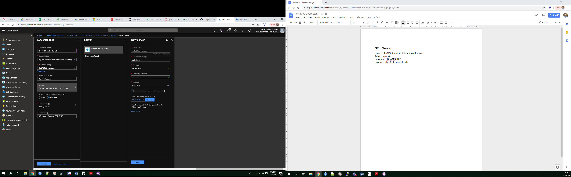

#### Notes:

* Name your database and server `**dsba6190-<GROUP>**`
* Change the pricing tier down to **Basic**

#### Questions

1. What is the username and password for your group’s database?

## Create an Azure Storage account **●**

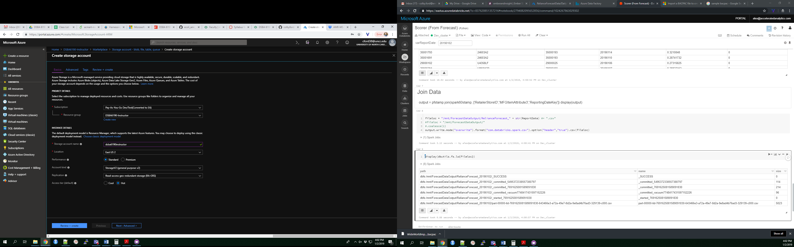

#### Notes:

* Name your storage account `**dsba6190<GROUP>**`
* Make sure your Location is **East US 2**.

## Upload Data Backup to Storage **●**

Upload the [***WideWorldImporters-Standard.bacpac***](https://github.com/colbyford/DSBA6190-Spring2019/raw/master/2%20-%20Data%20Platform/lab/WideWorldImporters-Standard.bacpac) file to the storage account.

#### Notes:

* You will have to create and name a blob container first.

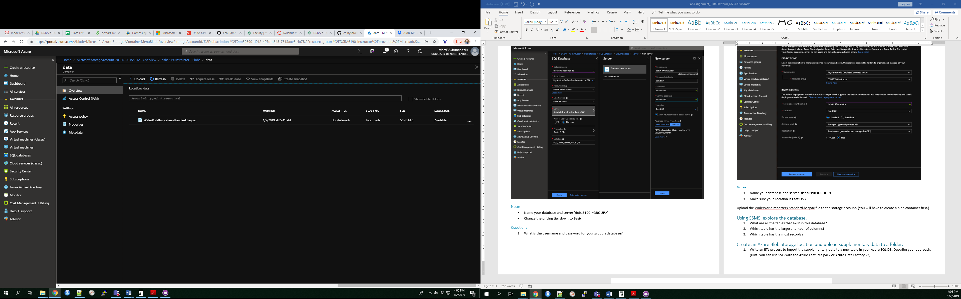

## Import the WideWorldImporters Database **●**

Using the instructions found [here](https://docs.microsoft.com/en-us/azure/sql-database/sql-database-import), import the .bacpac file from your storage container as a new database.

#### Notes:

* This will take a while. (Maybe up to 30mins.)
* You can read about the WideWorld Importers sample data [here](https://docs.microsoft.com/en-us/sql/samples/wide-world-importers-what-is?view=sql-server-2017).

## Explore the database.

#### Questions:

1. What are all the tables that exist in this database?
2. Which table has the greatest number of columns?
3. Which table has the most records?

## Upload supplementary data and import into the database.

Write an ETL process to import the supplementary data to a new table in your Azure SQL DB.

#### Questions:

1. Describe your approach.
2. What did you name the table? Provide a screenshot of the table.
3. Join the supplementary data to the original data. Provide a screenshot of the output.

#### Notes:

* Hint: you can use SSIS with the Azure Features pack or Azure Data Factory v2

## Understand platform selection differences.

#### Questions:

1. What are the capability differences in using Azure DB vs. Azure SQL DW?
2. What are the cost differences in using Azure DB vs. Azure SQL DW?
3. What are the capability differences in using Azure Blob Storage vs. Azure Data Lake Store?
4. What are the cost differences in using Azure Blob Storage vs. Azure Data Lake Store?